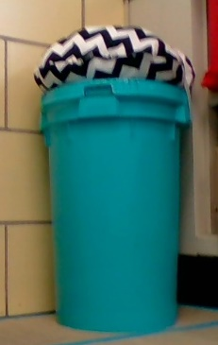 Bucket Seat Rules

1. The rules for sitting on this type of seat should be to careful and respect the seat, not to destroy or break it.

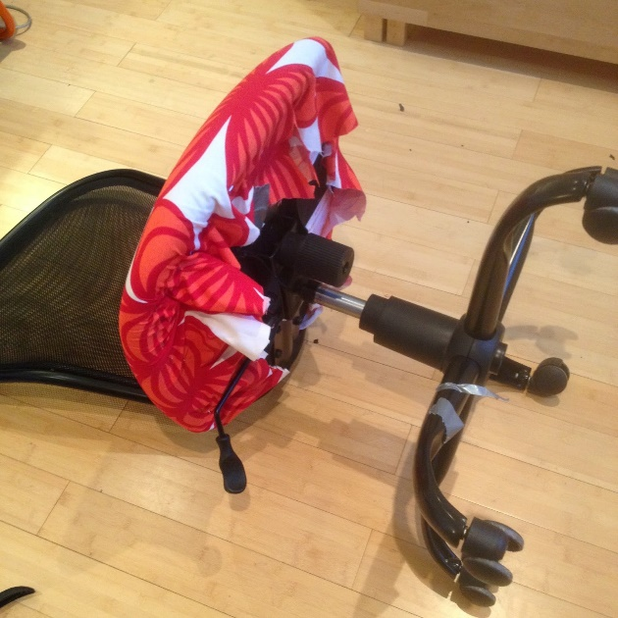

1. Some examples of things students should not do while using the seat would be not to violate the seat, since you do not own the seat.
2. 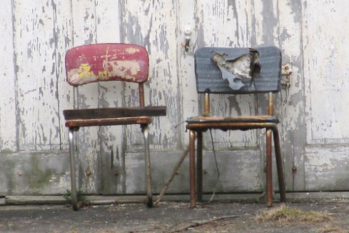
3. When choosing a seat like this during work time, what you should doing on the seat would be sitting on it quietly and focusing on your work.

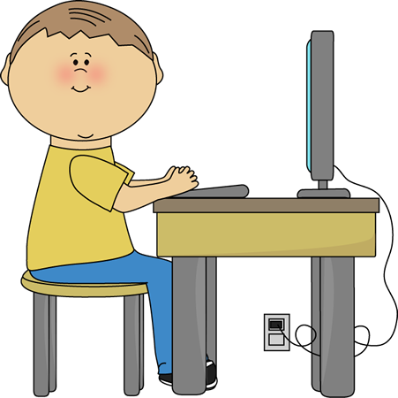

1. When worktime is done, you should put the seat back to the original spot from where you found the seat.

